E- SCHOOL

Muhammad Sa’ad Naasik: 1005092

Md. Tamzeed Islam: 1005094

Bashima Islam: 1005095

Md. Shamim Hasnath: 1005096

Akib Ibn Zahid: 1005098

# Table of Content

1. Actors
2. Subsystems
3. Use Cases of each Subsystem
4. Collaboration Diagram of each Subsystem
5. Class Diagram of each Subsystem

# Actors

* Student
* Parents
* Course Teacher
* Class Teacher
* Head Master
* System Administrator

# Subsystems

* User Profile Subsystem
* Student Profile Subsystem
* Coursework Subsystem
* Examination Subsystem
* Result Subsystem
* Notice Subsystem

# User Profile Subsystem

* Add/ Update User with Role
* Add/ Update/ Delete User Details
* View User Details
* Login
* Delete User

## Add/ Update User with Role



Figure 1: Collaboration Diagram of Add User with Role

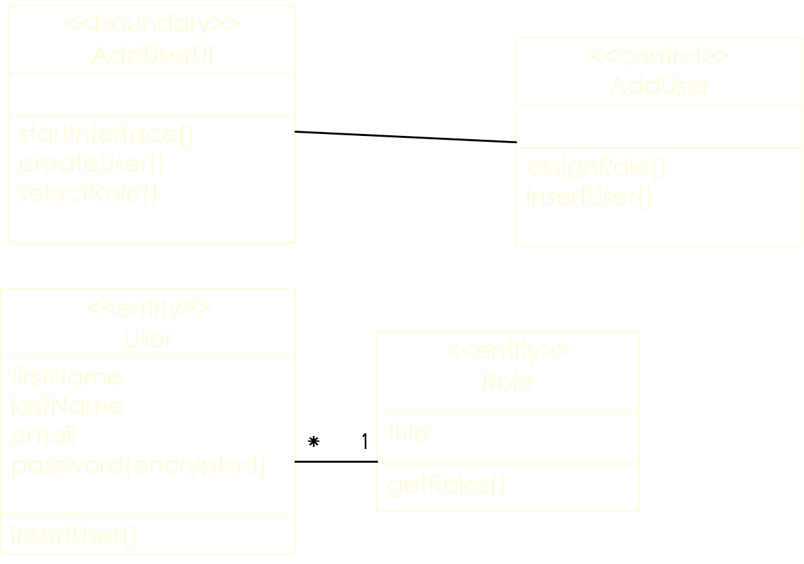

Figure 2: Class Diagram of Add User with Role

## Update User Role



Figure 3: Collaboration Diagram of Add/ Update/ Delete User Details

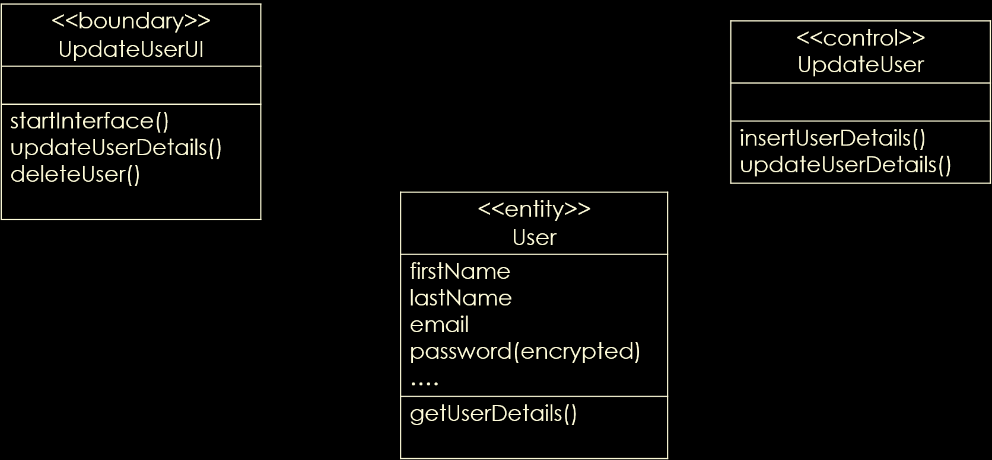

Figure 4: Class Diagram of Add/ Update/ Delete User Details

## View User Details



Figure 5: Collaboration Diagram of View User Details



Figure 6: Class Diagram of View User Details

## Login



Figure 7: Collaboration Diagram of Login



Figure 8: Class Diagram of Login

## Delete User



Figure 9: Collaboration Diagram of Delete User



Figure 10: Class Diagram of Delete User

# Student Profile Subsystem

* Update Fees Status
* View Fees Status
* Update Behaviour & Performance
* View Behaviour & Performance
* Update Attendance
* View Attendance

## Update Fees Status



Figure 11: Collaboration Diagram of Update Fees Status

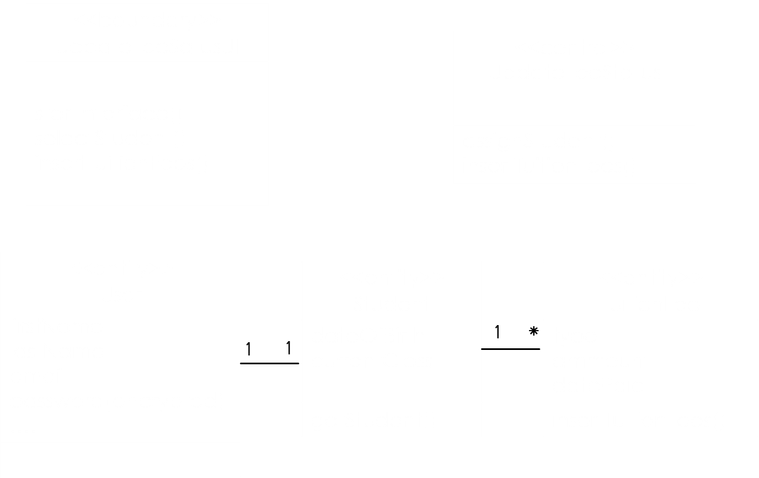

Figure 12: Class Diagram of Fees Status

## View Fees Status



Figure 13: Collaboration Diagram of View Fees Status

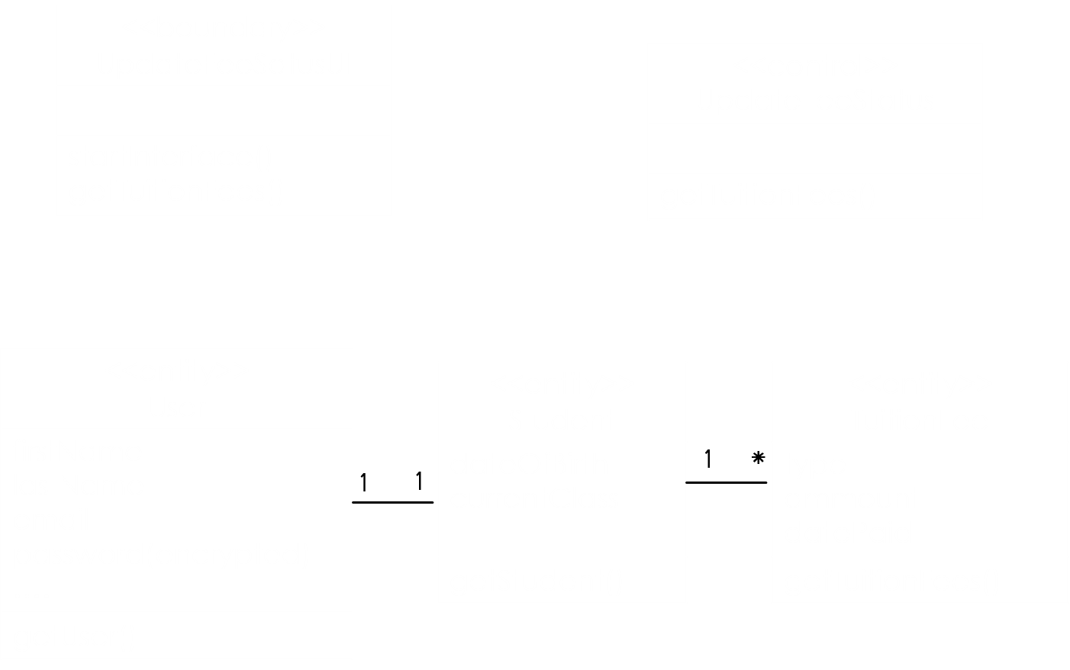

Figure 14: Class Diagram of View Fees Status

## Update Behaviour & Performance



Figure 15: Collaboration Diagram of Update Behaviour & Performance

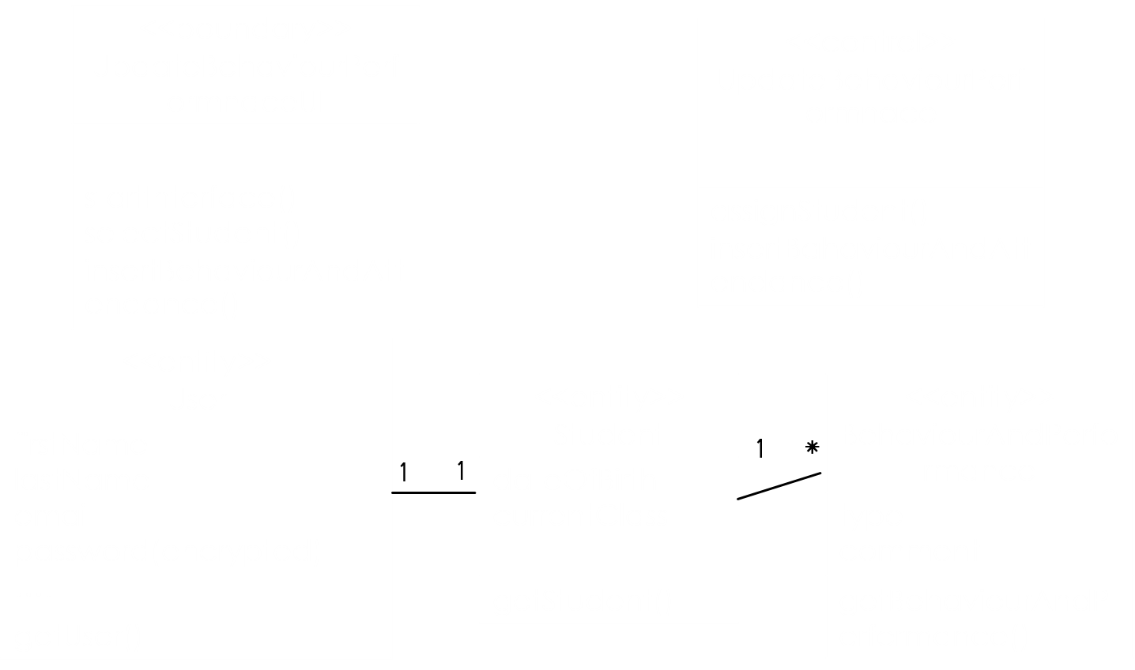

Figure 16: Class Diagram of Update Behaviour & Performance

## View Behaviour & Performance



Figure 17: Collaboration Diagram of View Behaviour & Performance

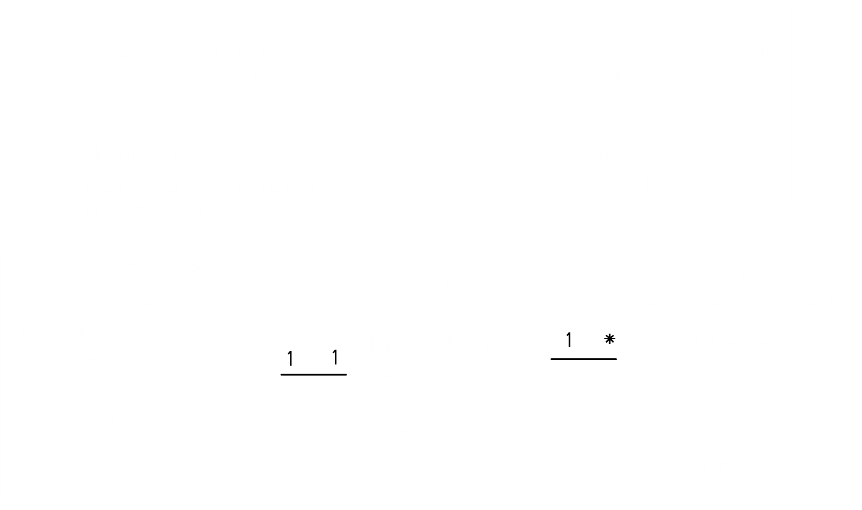

Figure 18: Class Diagram of View Behaviour & Performance

## Update Attendance



Figure 19: Collaboration Diagram of Update Attendance

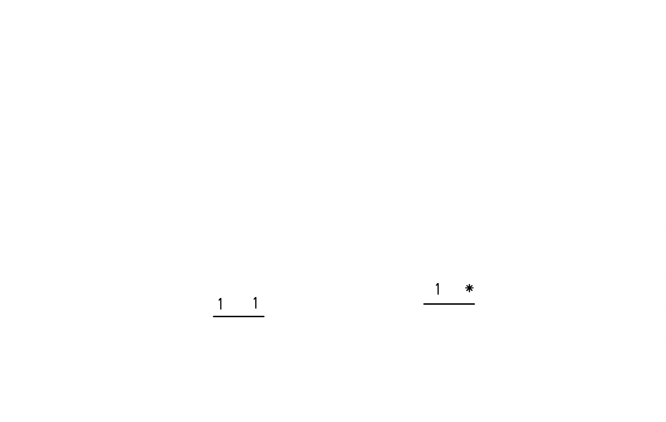

Figure 20: Class Diagram of Update Attendance

## View Attendance



Figure 21: Collaboration Diagram of View Attendance

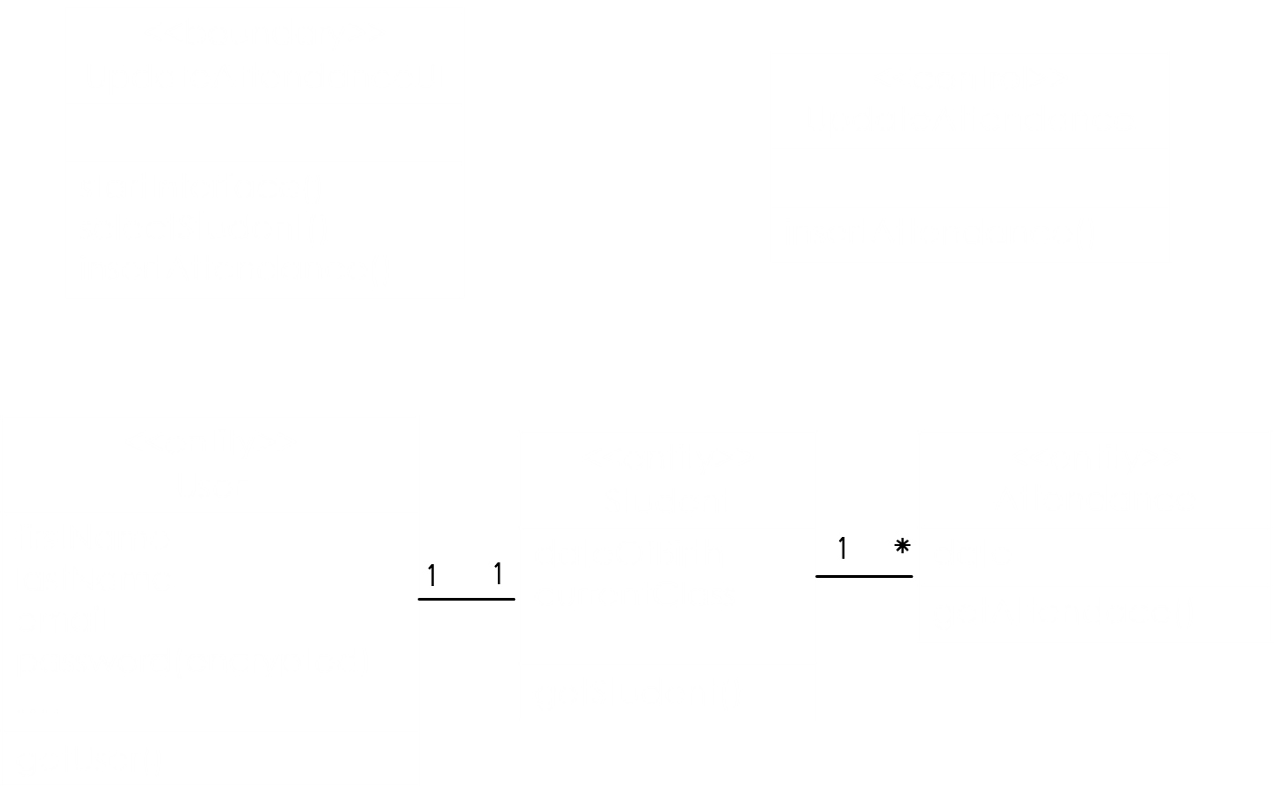

Figure 22: Class Diagram of View Attendance

# Coursework Subsystem

* Assign Course Teacher
* Prepare & Publish Routine
* View Routine

## Assign Course Teacher



Figure 23: Collaboration Diagram of Assign Course Teacher

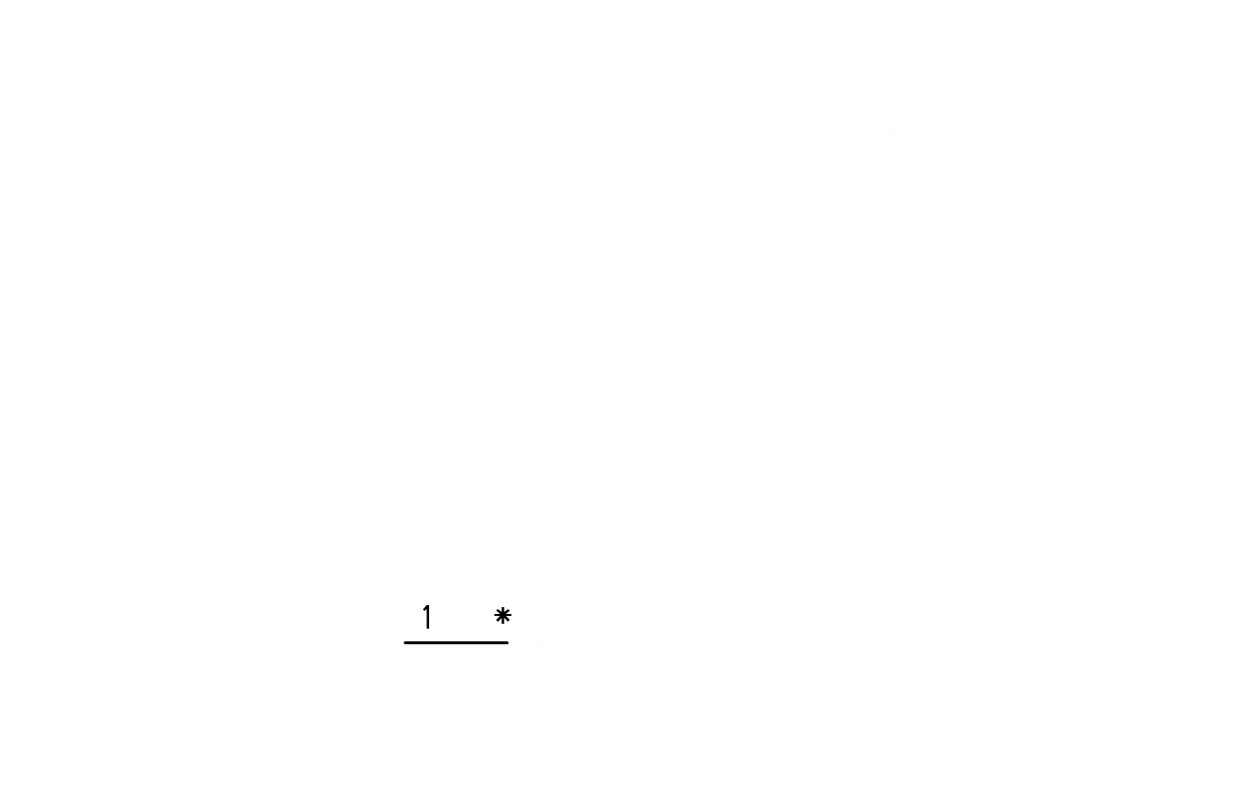

Figure 24: Class Diagram of Assign Course Teacher

## Prepare Routine



Figure 25: Collaboration Diagram of Prepare Routine

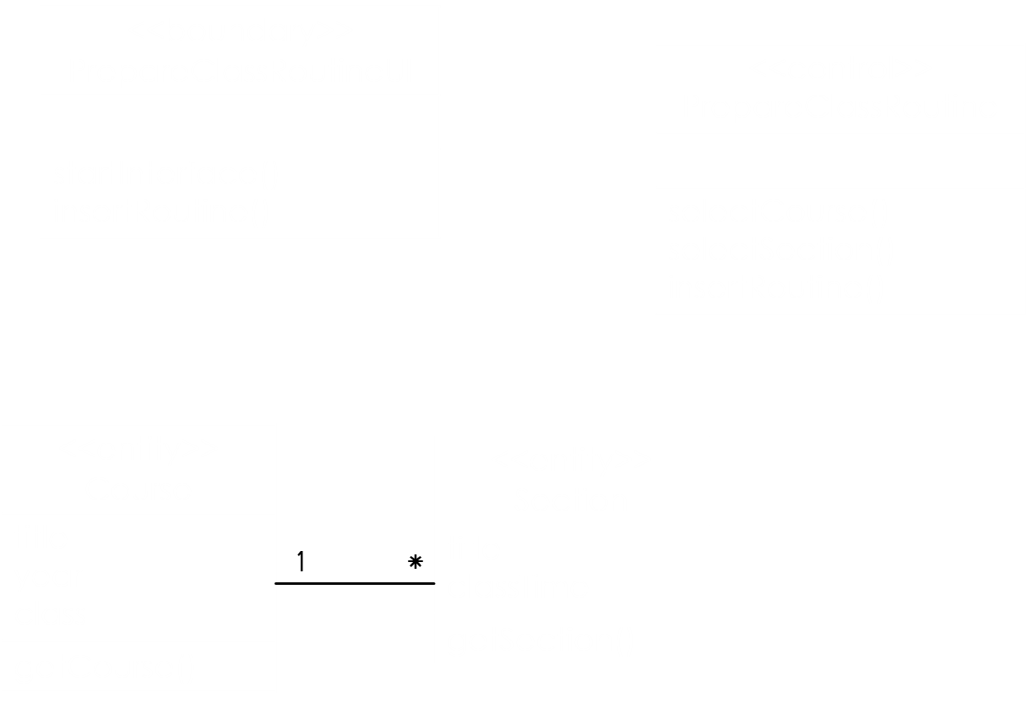

Figure 26: Class Diagram of Prepare Routine

## View Routine



Figure 27: Collaboration Diagram of View Routine

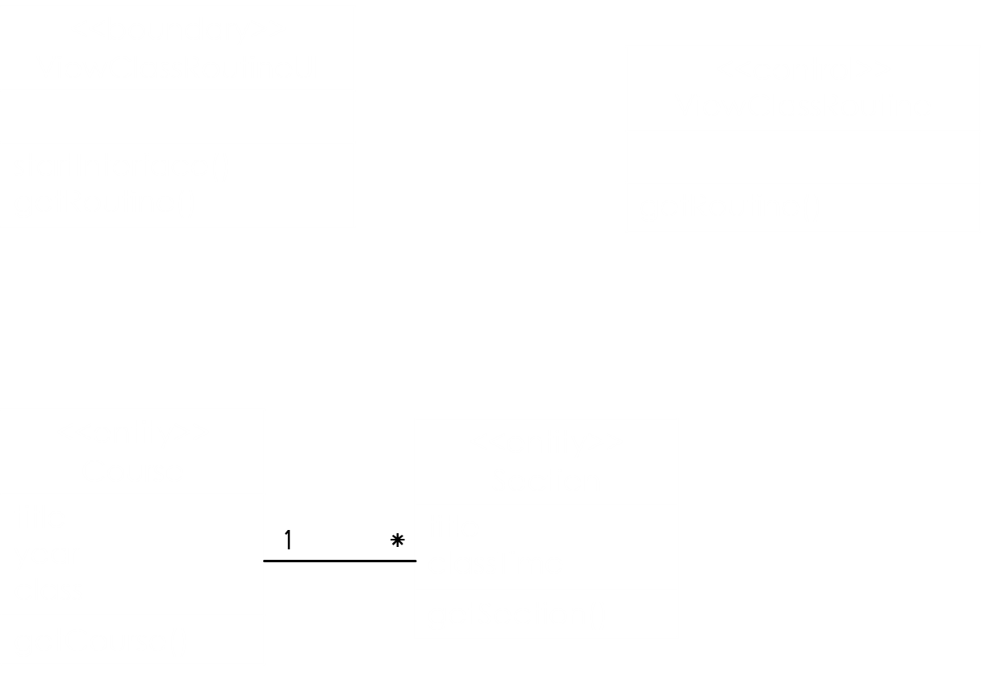

Figure 28: Class Diagram of View Routine

# Examination Subsystem

* Update Examination Schedule
* View Examination Schedule
* Insert Marks

## Update Examination Schedule



Figure 29: Collaboration Diagram of Update Examination Schedule

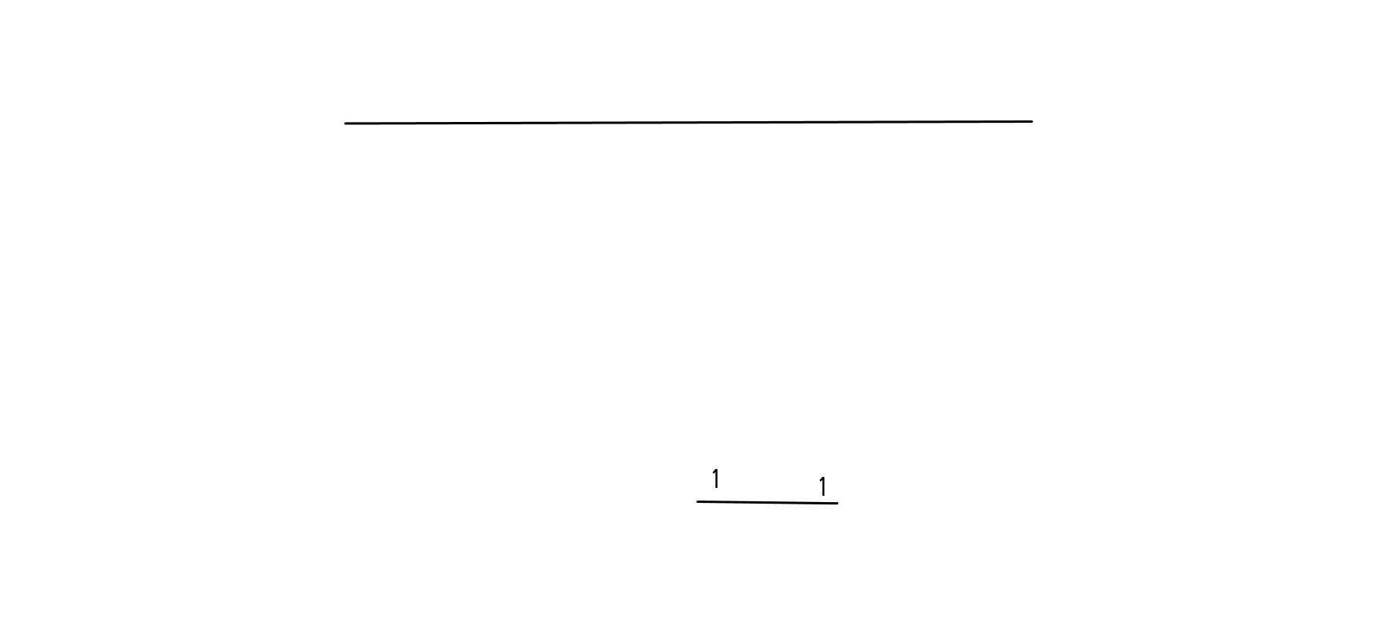

Figure 30: Class Diagram of Update Examination Schedule

## View Examination Schedule



Figure 31: Collaboration Diagram of View Examination Schedule

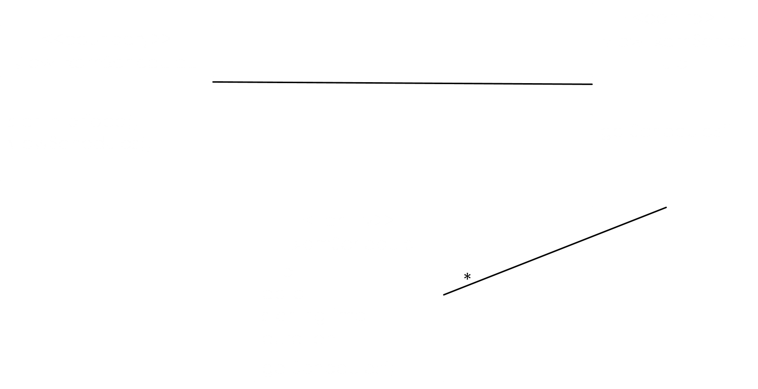

Figure 32: Class Diagram of View Examination Schedule

## Insert Marks



Figure 33; Collaboration Diagram of Insert Marks

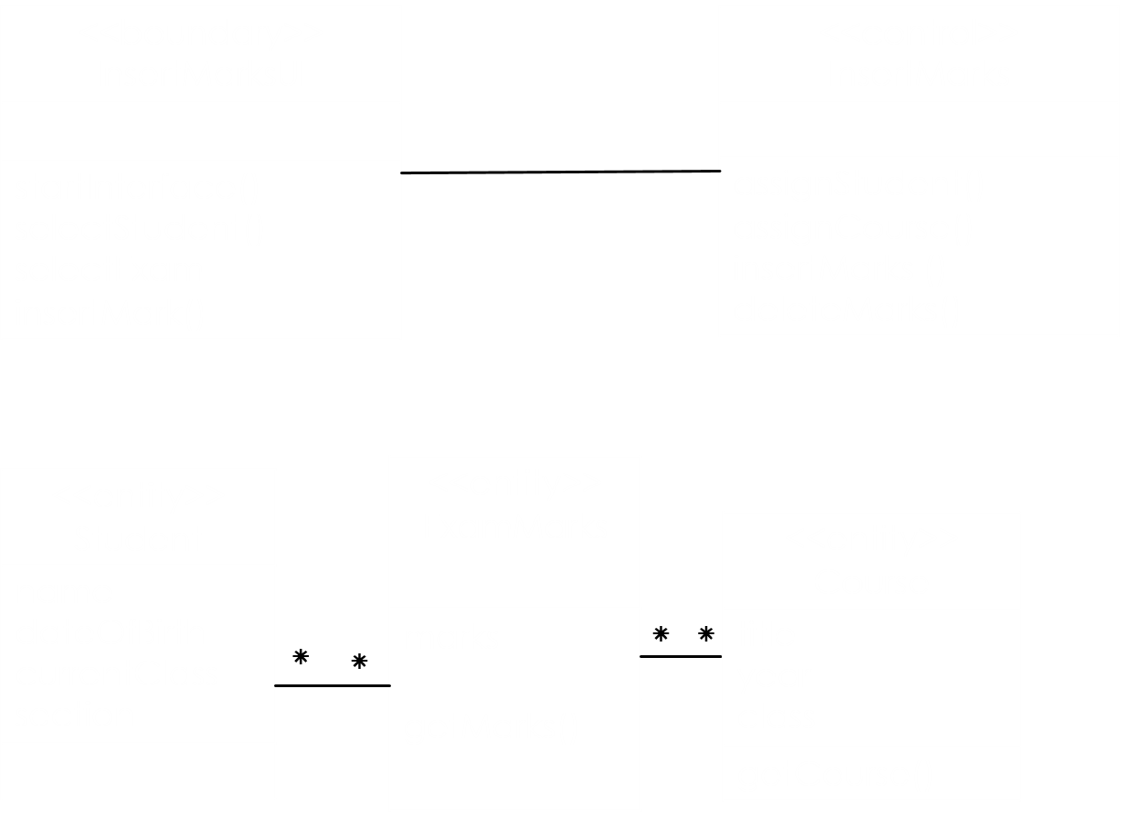

Figure 34: Class Diagram of Insert Marks

# Result Subsystem

* Prepare Result
* Forward Result
* View Result Summary & Approve
* Update Result
* View Result

## Prepare Result

### 

Figure 35: Collaboration diagram of prepare result

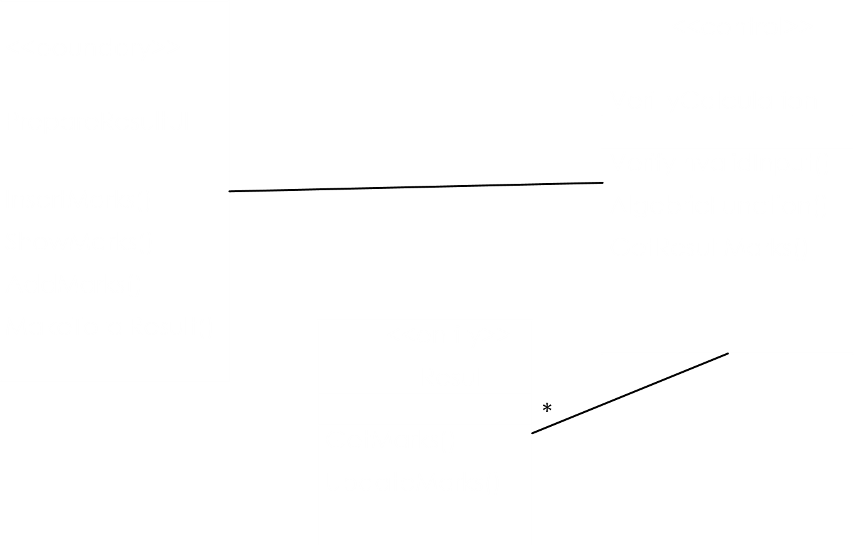

Figure 36: Class Diagram of Prepare Result

## Forward Result



Figure 37: Collaboration Diagram of Forward Result

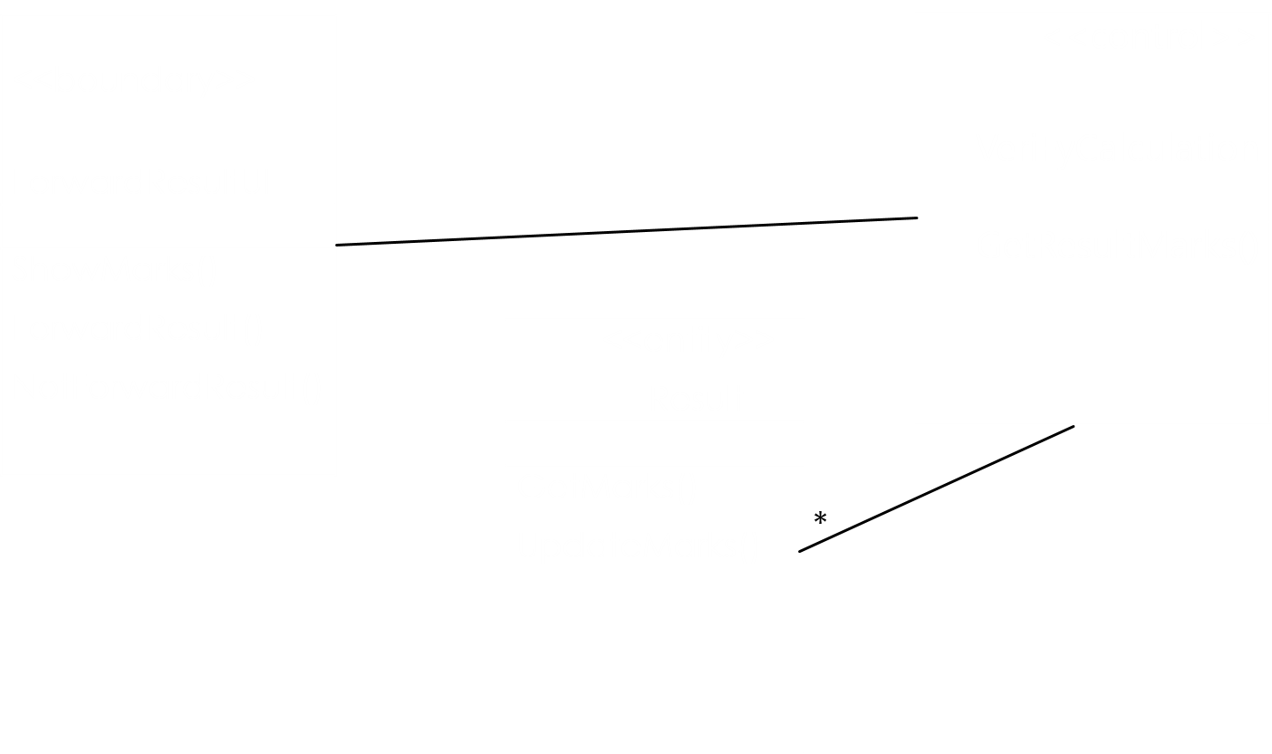

Figure 38: Class Diagram of Prepare Result

## View Result Summary & Approve



Figure 39: Collaboration Diagram of View Summary & Approve Result

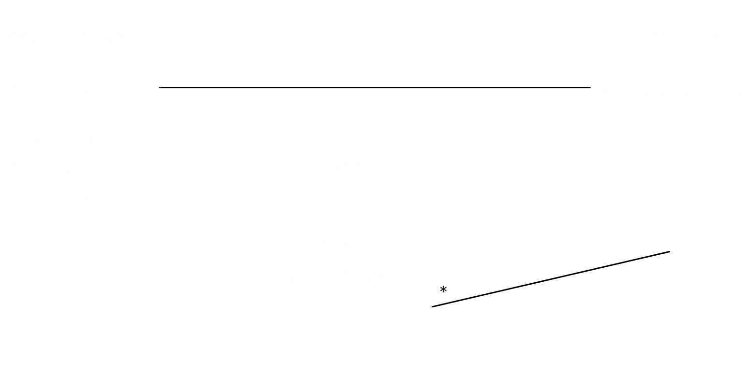

Figure 40: Class Diagram of View Summary and Approve Result

## Update Result



Figure 41: Collaboration Diagram of Update Result

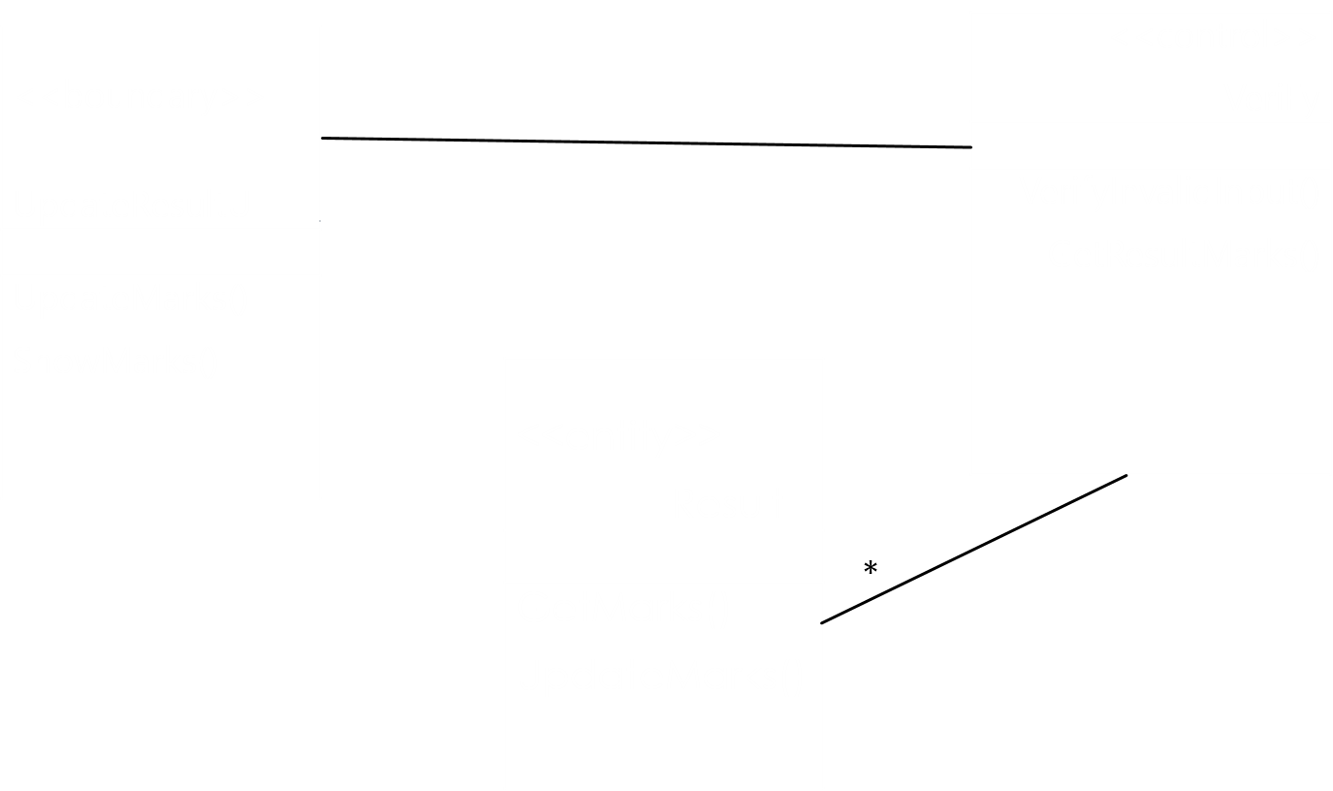

Figure 42: Class Diagram of Update Result

## View Result



Figure 43: Collaboration Diagram of View Result

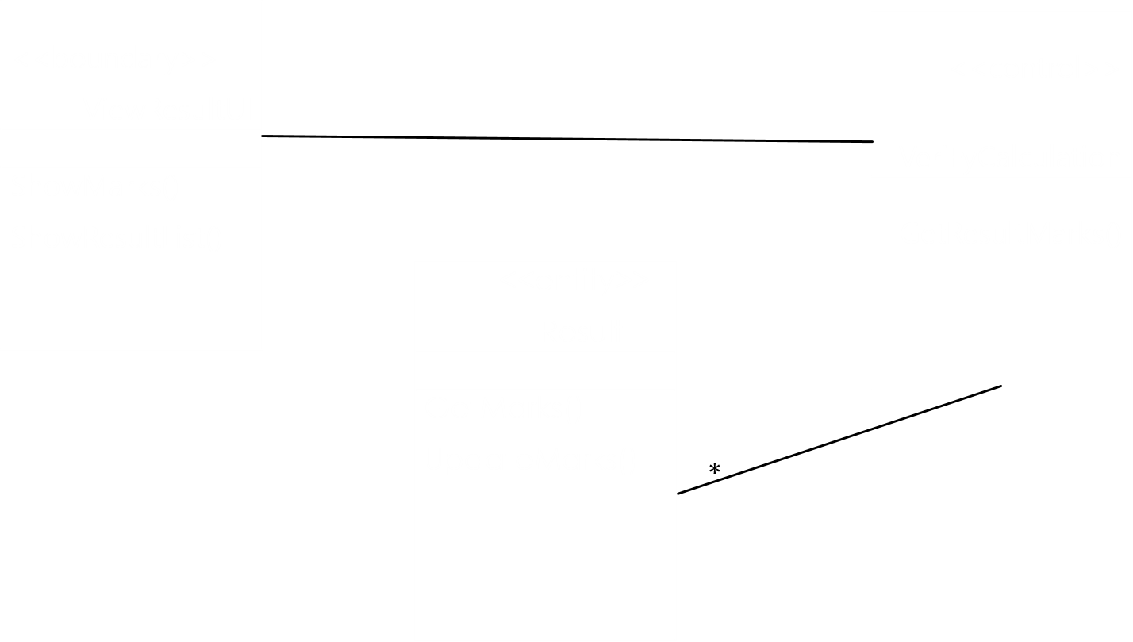

Figure 44: Class Diagram of View Result

# Notice Subsystem

* Update Notice
* View Notice

## Update Notice



Figure 45: Collaboration Diagram of Update Notice



Figure 46: Class Diagram of Update Notice

## View Notice



Figure 47: Collaboration Diagram of View Notice



Figure 48: Class Diagram of View Notice